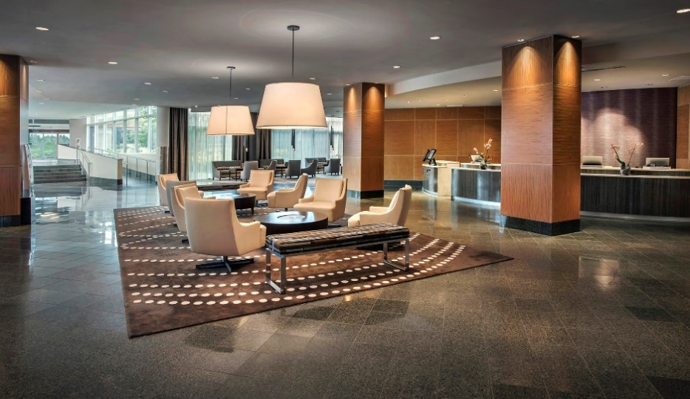

HYATT REGENCY PITTSBURGH INTERNATIONAL AIRPORT
1111 Airport Boulevard PO Box 12420 Pittsburgh, Pennsylvania 15231
USA

T +1 724 899 1234
F +1 724 899 6080
pittsburghairport.hyatt.com

ACCOMMODATIONS
336 stylish soundproof guestrooms, including 22 suites / parlors, 132 kings, 141 double / doubles (including 14 accessible rooms), and 18 Pure® hypo-allergenic rooms
All Accommodations Offer
- Hyatt Grand Bed®
- Wireless high-speed Internet access
- 42-inch LCD flat-screen television with remote control, cable movie channels
- Video messages, video account review and video check-out
- Voicemail, dual-line telephone and dataport
SERVICES & FACILITIES
• 1-800-CHECK-IN®
- Hyatt Web Check-In
- In-room dining
- Hyatt E-Concierge
- Business Center and support services
- Connected to car rental / airline ticket counters

RECREATIONAL FACILITIES

- Multilingual staff
- Assistive listening devices
- Safe-deposit boxes at front desk
- Complimentary shuttle up to seven mile radius of the surrounding area
- Soda and ice machines on each floor
- High-speed wireless Internet access in lobby and public areas

  - Individual climate control; electronic door lock
  - In-room laptop-sized electronic safe
  - Turndown service available upon request
  - Full bath amenities including hair dryer and make-up mirror
  - Coffeemaker with complimentary coffee
  - Iron / ironing board, luggage rack
  - iHome® alarm clock radio
  - Flexible work station with electrical outlets

RESTAURANTS & BARS
  - bellfarm Kitchen|Bar—a favorite among business and leisure travelers; featuring a locally inspired menu with a range of farm to table ingredients, including savory sandwiches, soups, salads, prime steaks and seafood;
serving breakfast, lunch and dinner
  - bellfarm Bar—serving craft cocktails, local spirits, local craft brews,
full dinner and lite fare menus available; Watch the latest sporting events on our f lat screen TV’s
  - bellfarm EXPRESS—Starbucks® coffee, fruits, pastries, sandwiches and salads-to-go
- Heated indoor lap pool, whirlpool, and dry sauna
- 24-hour Hyatt StayFit gym, includes Life Fitness® cardio and strength training equipment, elliptical cross-training bicycles, treadmills and weights (accessible for guests with guest room key)
- Minutes from several PGA rated golf courses

MEETING & EVENT SPACE
- A total of 20,000 sq. ft. of function space and 7,400 sq. ft. of prefunction space
- 23 flexible meeting rooms, including four boardrooms and three elegant ballrooms including the Regency Ballroom which is the largest hotel ballroom outside of downtown Pittsburgh; dinner seating for up to 650 guests
- The state-of-the-art Foerster Boardroom features conference table with built-in high-speed Internet access and analog lines
- All meeting rooms feature individual controls for heat / AC, sound, music, telephones, multiple electrical / microphone outlets, special lighting effects, 110V and 208V single-and three-phase electricity and food
and beverage stations
- Foyer space can accommodate up to 35 8’ x 10’ exhibit booths. Exhibit hall on same level as meeting space with dedicated load in / out dock
- High-speed wireless Internet connection, DS3 line dedicated to meeting and function space for high-speed Internet access
- Off-premises catering available through Hyatt Catering & Events
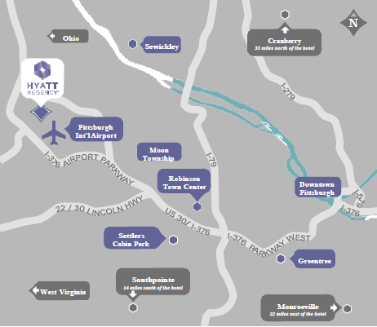

LOCATION
Elevate the travel experience by staying at the most convenient
airport hotel in the city for business or vacation. Hyatt Regency
Pittsburgh Int’l Airport is the only hotel connected to the Pittsburgh Int’l Airport terminal

VISITOR INFORMATION
  - Language: English
  - Currency: USD
  - Climate: Summers are warm / hot and sunny, while winters are cold and snowy; spring and autumn
varies yet mild
  - Visa: Please refer to your local travel consultant for visa
information prior to travel

TRANSPORTATION
  - Connected to the Pittsburgh Int’l Airport, our hotel is accessible via enclosed moving walkways

POINTS OF INTEREST
- David L. Lawrence Convention Center
- Pittsburgh Children’s Museum
- Carnegie Museum of Art & Natural History
- Frick Museum
- Andy Warhol Museum
- Station Square, an entertainment and dining complex
- PNC Park, home of the Pirates
- Heinz Field, home of the Steelers
- PPG Paints Arena, home of the Penguins
- 31 colleges and universities, including University of Pittsburgh, Robert Morris, Carnegie Mellon and Duquesne University
- Carnegie Science Center
- Heinz Hall for the Performing Arts
- Pittsburgh Public Theater
- Point State Park
- Strip District
- Key Bank Pavilion

